String Literal

Definition:
# Source: AI Source: Provided by: [Data Path: Persons Table -> ID Column: 1, Name_En Column: Motasem Essam] -> From: [Chatgpt (GPT‑5 Mini)] on [1/26/2026]
A string literal is a sequence of characters written directly in the source code and enclosed in quotes. It represents a constant string value that the program can use.

Key Points
# Source: AI Source: Provided by: [Data Path: Persons Table -> ID Column: 1, Name_En Column: Motasem Essam] -> From: [Chatgpt (GPT‑5 Mini)] on [1/26/2026]
- Always enclosed in double quotes "..." in most languages (single quotes are usually for single characters).
- Stored as a read-only sequence of characters in memory.
- Automatically includes a null character \0 at the end in languages like C and C++.
- Cannot be changed (immutable) in some languages like Python or Java.

Examples
# Source: AI Source: Provided by: [Data Path: Persons Table -> ID Column: 1, Name_En Column: Motasem Essam] -> From: [Chatgpt (GPT‑5 Mini)] on [1/26/2026]
1. Python
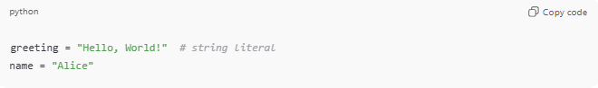
greeting = "Hello, World!" # string literal
name = "Alice"
2. C
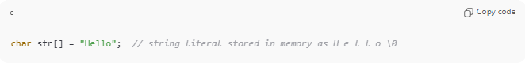
char str[] = "Hello"; // string literal stored in memory as H e l l o \0
3. Java
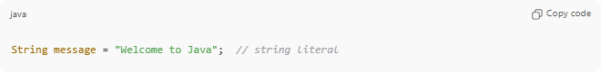
String message = "Welcome to Java"; // string literal

Difference Between String and String Literal
# Source: AI Source: Provided by: [Data Path: Persons Table -> ID Column: 1, Name_En Column: Motasem Essam] -> From: [Chatgpt (GPT‑5 Mini)] on [1/26/2026]
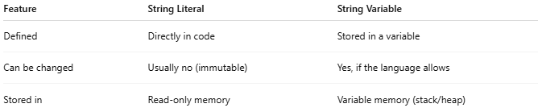
Feature | String Literal | String Variable
Defined | Directly in code | Stored in a variable
Can be changed | Usually no (immutable) | Yes, if the language allows
Stored in | Read-only memory | Variable memory (stack/heap)
Example:
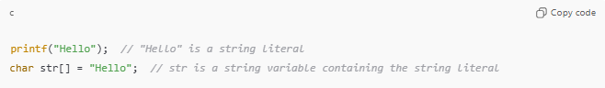
printf("Hello"); // "Hello" is a string literal
char str[] = "Hello"; // str is a string variable containing the string literal

Analogy
# Source: AI Source: Provided by: [Data Path: Persons Table -> ID Column: 1, Name_En Column: Motasem Essam] -> From: [Chatgpt (GPT‑5 Mini)] on [1/26/2026]
- String literal → A printed word on a sticky note
- String variable → A blank sheet where you can write or change words

✅ Summary
# Source: AI Source: Provided by: [Data Path: Persons Table -> ID Column: 1, Name_En Column: Motasem Essam] -> From: [Chatgpt (GPT‑5 Mini)] on [1/26/2026]
- String literal = sequence of characters directly in code
- Enclosed in quotes
- May include a null character (\0) in C/C++
- Represents a constant string value

